**EXPERIMENT 9**

**DATE: 18/02/2020**

**[E-R Modeling from the Problem Statements](http://vlabs.iitkgp.ernet.in/se/4/)**

* Entity Relationship Model
* Entity Set and Relationship Set
* Attributes of Entity
* Keys
* Weak Entity

**E-R Modelling from the Problem Statements**

**ENTITY RELATIONSHIP DIAGRAM (ERD)**

**Entity – Relationship Diagram:**

This depicts relationship between data objects. The attribute of each data objects noted in the entity- relationship diagram can be described using a data object description. Data flow diagram serves two purposes:

1. To provide an indication of how data are transformed as they move through the system.

2. To depict the functions that transformation the data flow.

**Data Objects:**

A data object is a representation of almost any composite information that must be understood by the software. By composite information, we mean something that has a number of different properties or attributes. A data object encapsulates data only there is no reference within a data object to operations that act on the data.

**Attributes:**

Attributes define the properties of a data object and take on one of three different characteristics. They can be used to: Name an instance of data object. Describe the instance

**Relationships**:

Data objects are connected to one another in a variety of different ways. We can define a set of object relationship pairs that define the relevant relationships.

**CARDINALITY AND MODALITY:**

**Cardinality:**

The data model must be capable of representing the number of occurrences of objects in a given relationship. The cardinality of an object relationship pair is

* **One-T0-One (1:1):**

An occurrence of object ‘A’ can relate to one and only one occurrence of object ‘B’ and vice-versa.

* **One-To-Many (1:N):**

One occurrence of object ‘A’ can relate to one or may occurrences of object ‘B’ but an occurrence of object ‘B’ can relate to only one occurrence of object ‘A’.

* **Many-To-Many (M: N):**

An occurrence of ‘B’ and an occurrence of ‘B’ can relate to one or many occurrence of ‘A’

**Modality:**

The modality of a relationship is zero if there is no explicit need for the relationship to occur or the relationship is optional. The Modality is one if the occurrence of the relationship is mandatory. The object relationship pair can be represented graphically using the Entity Relationship Diagrams. A set of primary components are identified for the Entity Relationship Diagram,

1. Attributes

2. Relationships

3. Various Type Indicators

The primary purpose of the Entity Relationship Diagram is to represent data objects and their relationships.

**Entity Set and Relationship Set**

**Entity set:**

An entity is an object that exists and is distinguishable from other objects. For instance, John Harris with S.I.N. 890-12-3456 is an entity, as he can be uniquely identified as one particular person in the universe.

* An entity may be concrete (a person or a book, for example) or abstract (like a holiday or a concept).
* An entity set is a set of entities of the same type (e.g., all persons having an account at a bank).
* Entity sets need not be disjoint. For example, the entity set employee (all employees of a bank) and the entity set customer (all customers of the bank) may have members in common.
* An entity is represented by a set of attributes.

E.g. name, S.I.N., street, city for ``customer'' entity.

* The domain of the attribute is the set of permitted values (e.g. the telephone number must be seven positive integers).

**Relationship Set:**

A relationship type represents the **association between entity types**.

For example, “Buying” is a relationship type that exists between customer and product owner.

**ENTITY RELATIONSHIP DIAGRAM FOR SMALL SCALE BUSINESS WEBSITE**

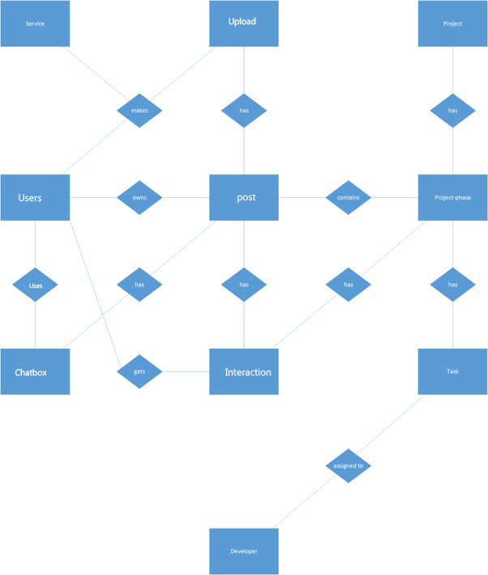

**1.Key Attribute**:  
 The attribute which **uniquely identifies each entity** in the entity set is called key attribute.

**For example, Login ID is unique for each customer**

Log in ID

**2.Composite Attribute:**

An attribute composed of many otherattribute is called as composite attribute.

For example, Address attribute of customer Entity type consists of Street, City, State, and Country. In ER diagram, composite attribute is represented by an oval comprising of ovals.

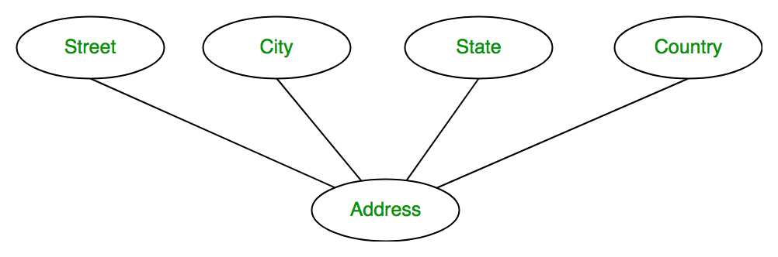

3.**Multi valued Attribute:**

An attribute consisting more than one value for a given entity. For example, Phone No (can be more than one for a given customer). In ER diagram, multi valued attribute is represented by double oval.

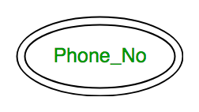

4. **Derived Attribute:**

An attribute which can be derived from other attributes of the entity type is known as derived attribute.

E.g.; Age (can be derived from DOB). In ER diagram, derived attribute is represented by dashed oval.

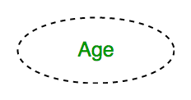

**Weak Entity:**

As discussed before, an entity type has a key attribute which uniquely identifies each entity in the entity set. But there exists **some entity type for which key attribute can’t be defined.** These are called Weak Entity type.

For example, A hotel may store the information of dependents (Parents, Children, Spouse) of an Employee. But the dependents don’t have existence without the employee. So Dependent will be weak entity type and Employee will be Identifying Entity type for Dependent. A weak entity type is represented by a double rectangle. The participation of weak entity type is always total. The relationship between weak entity type and its identifying strong entity type is called identifying relationship and it is represented by double diamond.

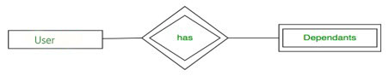

|  |  |  |  |
| --- | --- | --- | --- |
| **Presentation (4)** | **Documentation (3)** | **Explanation (3)** | **Total (10)** |
|  |  |  |  |